In this lesson we are going to be downloading some video footage from the Internet and we are going to import it in our natron and then we will be applying some filters to it and we are gonna do some enhancing and just gonna go through some different option for cleaning up footage and making it look nicer so we are gonna grab this and from pixaboy.com

We will search videos where they will

We search water. The video we are going to use should have good skin tone(who knows)

That we can kind of clean up and make it look nicer so we choose below video

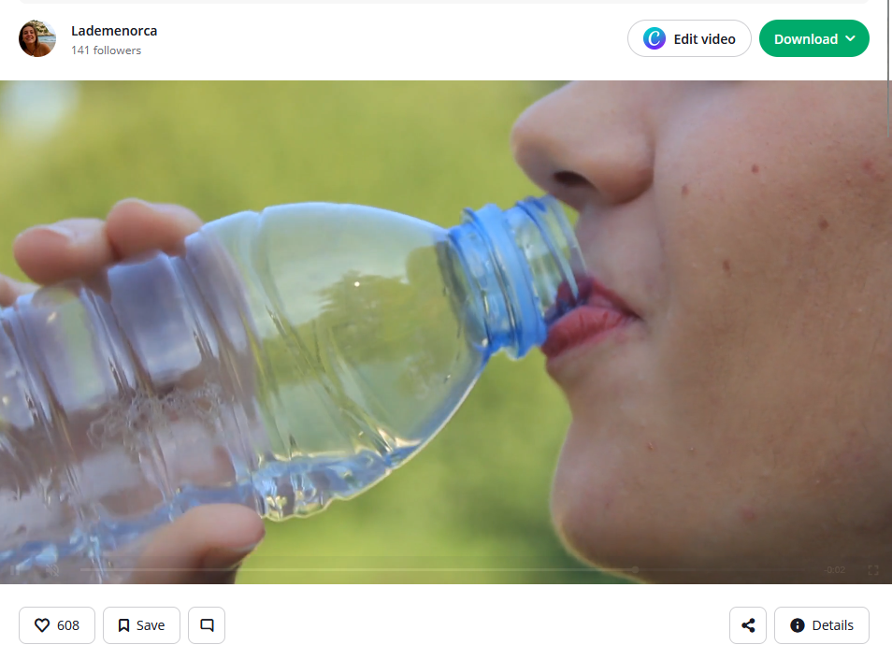

This is a great video to use in our project

Now we download it at 1920 X 1080 resolution so its full hd. Now we drag and drop the video to natron in node graph .Now node graph has a read node reading from the video Now it will look like below

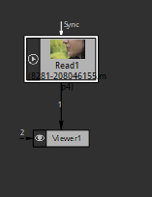

And we can read it indirectly So now we have our video we can play it its mp4 we are gonna notice have some artifacting

**Meaning:-**

**Artifacting** in video editing (or video processing) refers to **unwanted visual distortions** or **errors** that appear in a video, usually due to **compression**, **rendering issues**, or **hardware problems**.

There is some artifacting happening as shown below in Teacher not in mine (maybe becasue I have updated version of natron)

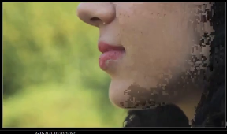

From what teacher van gather this happens because of the way natron reads in certain video files

Teacher think that its mp4 and the way natron reads it. In the first few frames it’s doing this artifacting it make it look kind of choppy and like these pixel are not displaying property within the rest of the video but it have some lingering artifacting

Teacher did some trick to correct (maybe I will do in future if I get stuck)Now we go to read node properties and then in list beside before feature as marked below

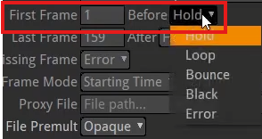

Change this hold to any other option Teacher change it to black it goes away as shown below

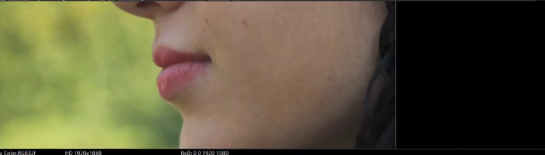

Noe even if we again choose Holf then this time it will not show any artifacting and now it should be good for the whole rest of the video

2:37

We should not see any of the artifacting so we are good Teacher will make a future lesson after he figure out more about why that happens and he think it’s just a glitch in natron because we don’t see it happening anymore after if we apply this technique. You need to do it on the frame where there is glitch okay so now have this video in here and this video is 159 marked below

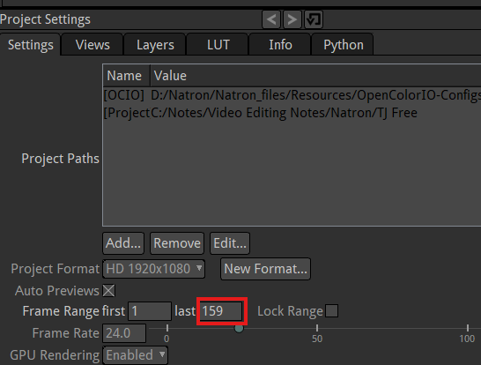

We are gonna read only 40 frames so enter 40 in marked above

So we start at frame 1 and then end at 40 frame. So now the project is 40 frames we are reading in 40 frames that just Now in Teacher Natron since he change the frame range so we will go to the frame where there is a glitch and then we will apply the technique and it will become OK. So now it’s in reading properly and then we render it out properly whatever we see in our preview in Viewer panel as far as having artifacting or messed up video. It will also translate. When it’s out and it will be in out final video

One more thing is that our frame rate of our project id 24 frame per second in out project settings this video is being played at 23.976 as marked below

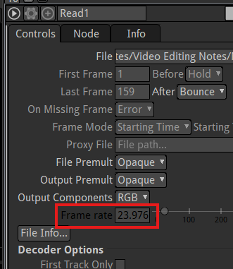

So probably not an issue although but it will be an issue since they both are not exactly equal even though the 23.97 will round off to 24. They should be exactly because if we add this video read node to the merge node and then you add another node(from Natron like noise) on merge node it will show a warning the project frame rate and video frame rate are not equal **the defect will only be visible when the frame rate gap will be huge**

So we want to change either our the frame rate of our project to match the video which is kind of best thing to do we just set the value of video equal to 24.Now both the video and project are equal to each other and now we won’t have that problem so if we add video and the node from natron then no warning will be shown we just remove the merge node as we don’t need it All we gonna do is that apply some filters here to this video so it will look nicer so one thing that’s always look good to do is you add grade node in the node graph by going to marked tool group in the toolbar

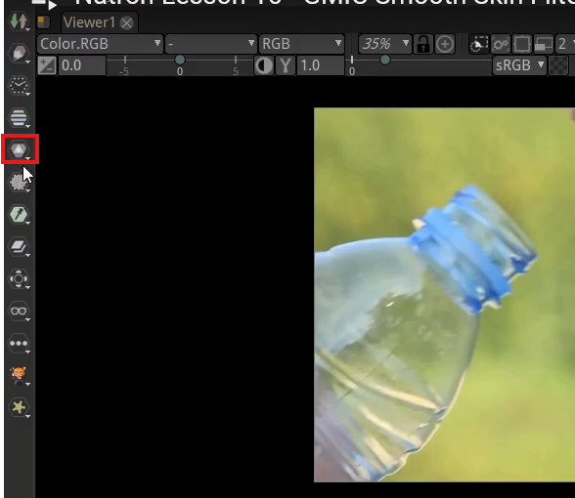

And then in menu choose grade as marked below

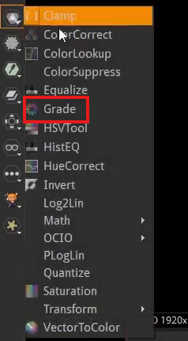

And we will place it between the read node and viewer node so now we can so color grading

5:44

This is actually pretty decent colors but we can see shown below in the hair little bit is sort of brown and greys. It’s not really deep vibrant like a really dark color so we can select our black point on this grade node

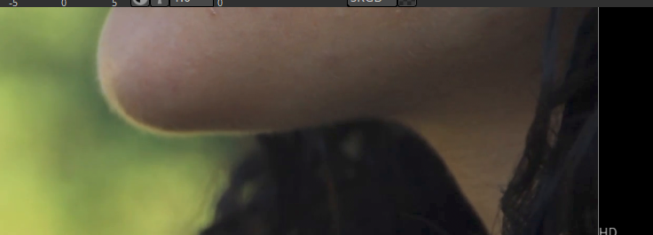

And take its color picker as marked below in Grade node panel

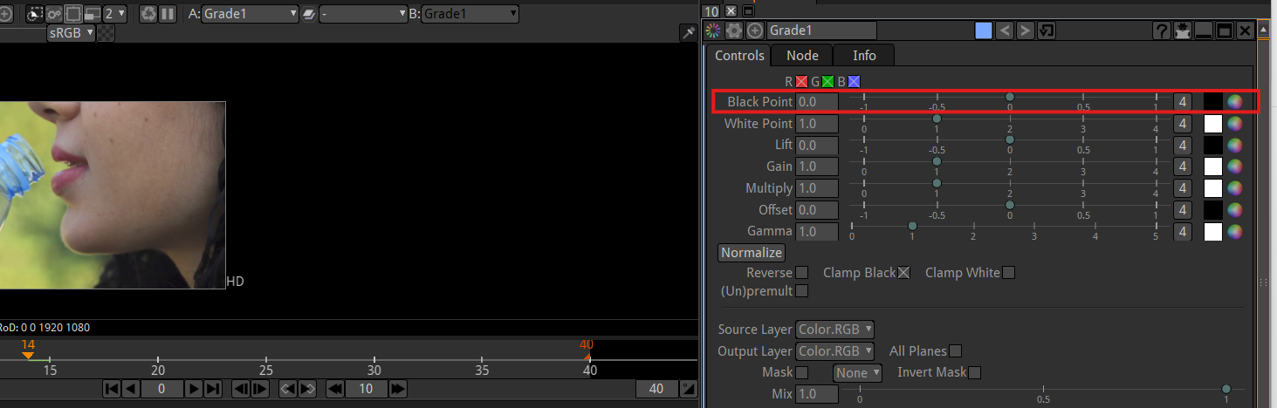

And then we choose the point incorrectly as marked below

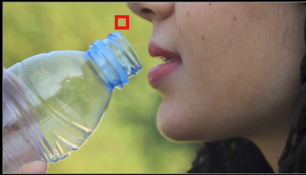

Then it will be like below

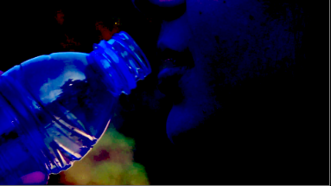

So here basically we have told hey this ius a very dark pixel and it says if there is a very dark pixel then all other pixel will adjust them accordingly ( maybe it basically making all the pixel containing color instances(which we sampled through color picker ) to the dark pixel. ) so they look good in relative to this one datd pixel we selected (who knows)

You can undo all the operation you have done through a panel related to a node by clicking on the marked below

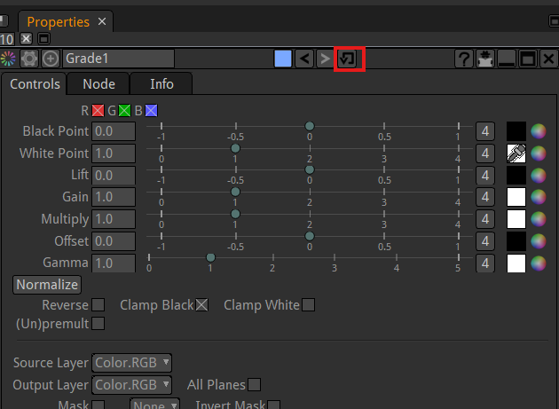

If you click there on any node then it will reset back to its original it will restore default values so instead of doing green now we will select that is pretty close to black maybe this in marked below

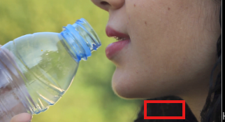

So now for black point we choose the marked point and you see it makes our hair lot darker as shown below

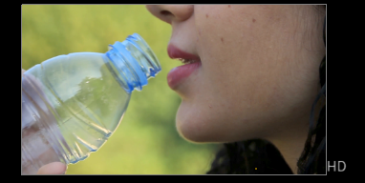

If we select then grade node and hit the d key on the keyword we can see kind of change by activating and deactivating grade node now instead of being flat and grey it just make a lot more vibrant and deep it even affects some of the other pixel in the shoot too. Now the same thing as white point so we go to this grade node and select this white point color picker and we choose a really white light point so we go to frame 13 and marked below is the most white part

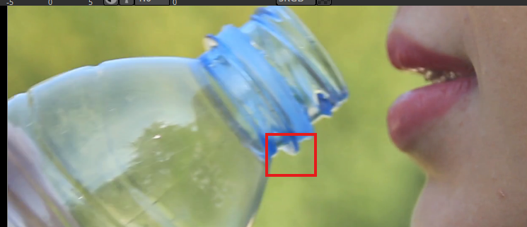

Now that portion will be more whitish as shown below

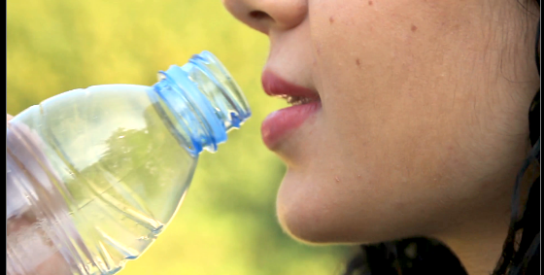

Use the d key to enable and disable the grade node to see the difference in the output

Best way to see before and after is to get another viewer and so sometimes when we are doing color grading or changing the shots like this we will just add in a second viewer and just attach the source node to the viewer2 node

Now we can see difference between the outputs after and before the grade node(we have studied before)

Noe by making the viewer side by side and see the difference by playing each of them from the beginning of the shot

8:41

and play them next to each other and see what it looks like as shown below

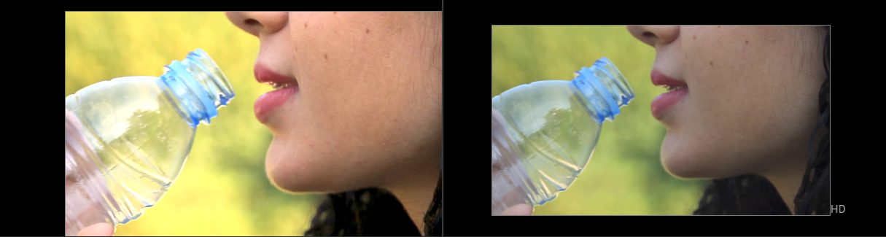

Like before and after and so drinking the water

Teacher did not like this after so he did choose another point for white point in the frame

You can variate your color chosen for white point by going to color picker and variate your chosen color we just variate the color we get by choosing the point you can really change all the color feel of the shot (who knows)

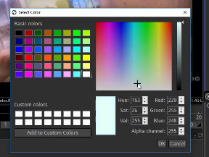

Teacher think it is good and we have nice to the hair is a deeper darker color the whites are little more vibrant.

**Note:-**

I think the white point make the color present in any pixel more vibrant

Now lets do the smooth out the skin a little bit

Now there are GMIC filters which we had to add it by external sources but in newer version it come by default so if you have older natron then kindly update it

The GMIC filers are really just cool different filters you can apply to your video like if you go to artistic by click on the marked below

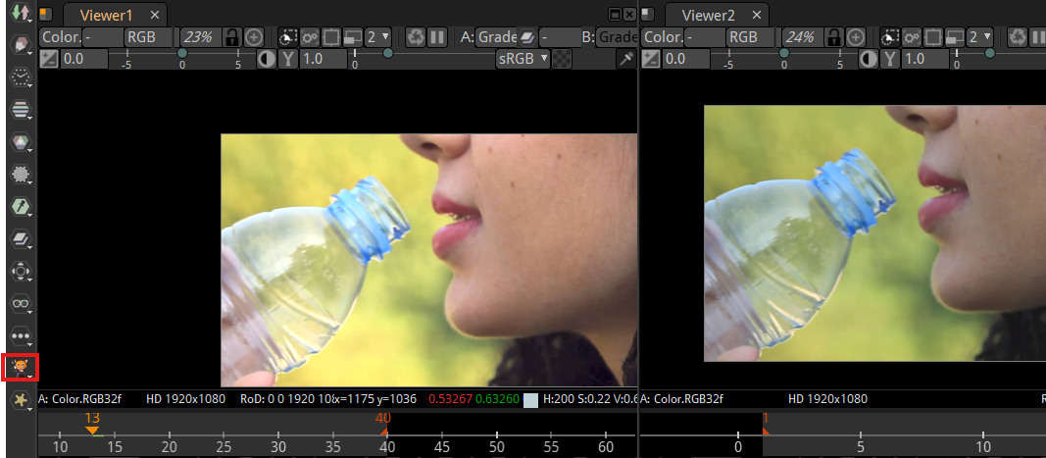

Now in the submenu opened go to artistic as highlighted below

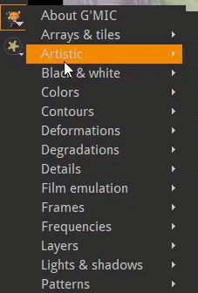

And then in artistic we can choose many option but we choose GMIC cartoon as highlighted below

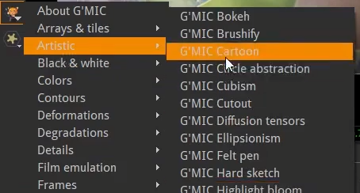

We take it for an extreme one Now out node graph has GMIC as marked below

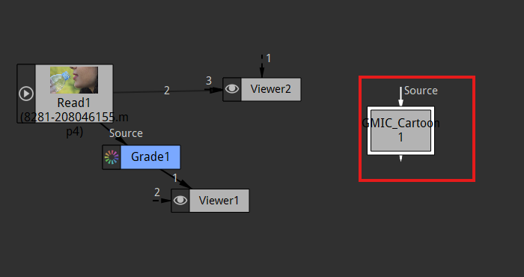

Now we place it between the viewer node and the grade node as shown below

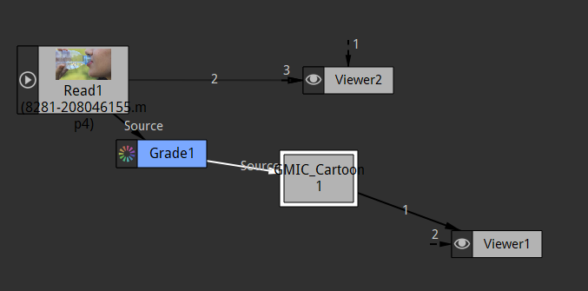

Now in our viewer 1 it will look cartoony as shown below

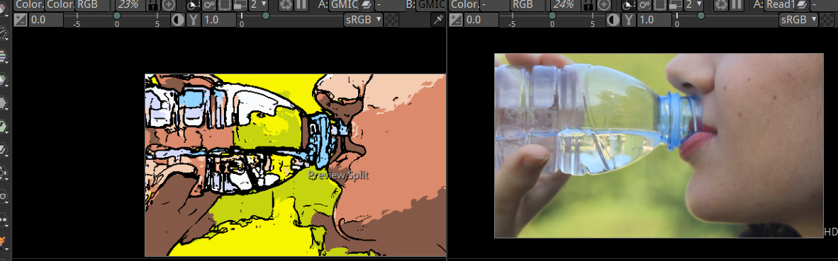

Now if we go to this properties then you can see many properties to handle the cartoonish in the footage

We make it sort of look like a cartoon we don’t want to apply that one so we delete it.

Noe teacher try to find the smooth skin in the GMIC teacher could not find it so by the help of tab we search smooth skin and then press enter but I have found it so for it first go to GMIC and then to repair and then to Smooth skin as highlighted below

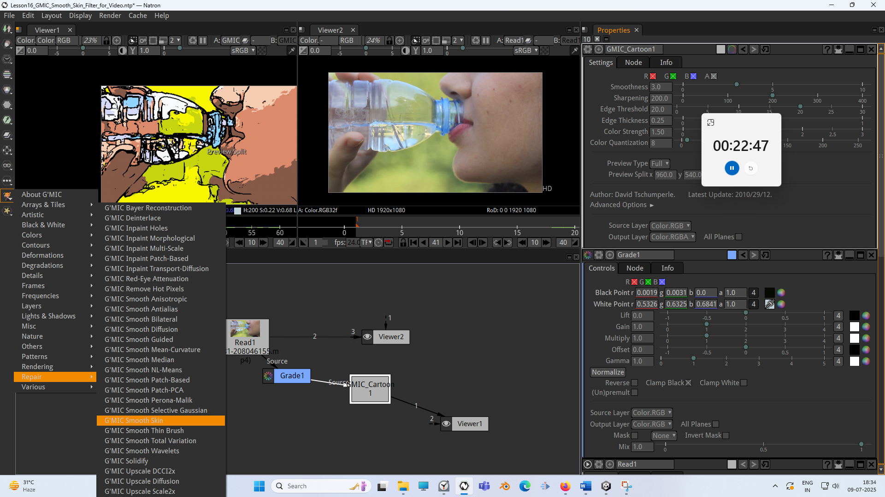

Now in node graph it will look like below

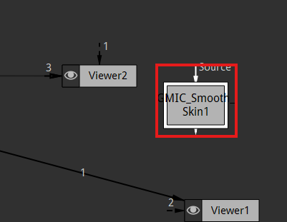

And now we place it between the Grade1 node and viewer node as shown below

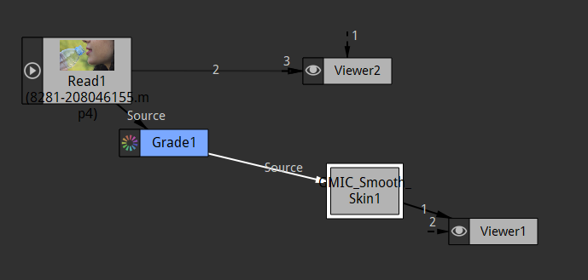

So now we have a smooth skin filter and it is already doing smoothing without doing any adjustment

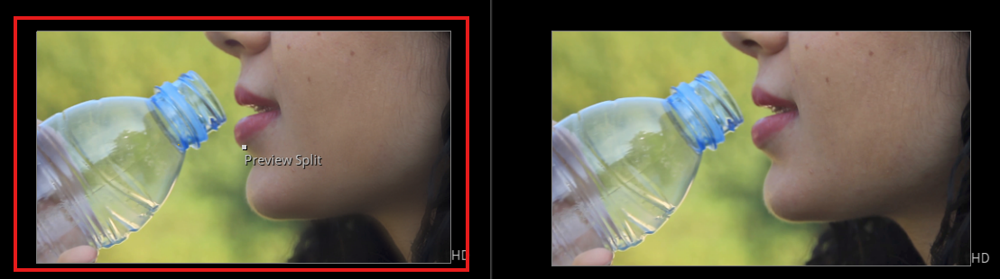

As marked above

You will notice it when you zoom into the skin as marked below

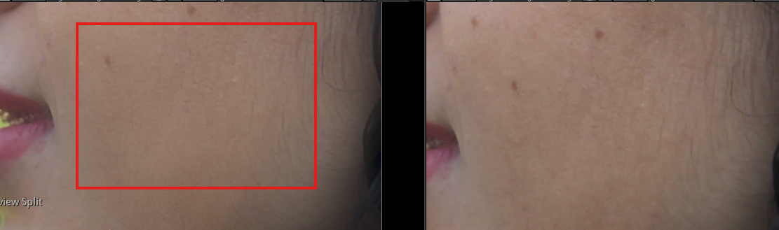

Now you can see in left hand side where the smooth is applied

11:21

It just smoother and see how much nicer that skin and lips look like everything just smoother and nice so that’s pretty cool and it takes a while to do this smooth skin it takes a while to render so if we are gonna back and play through the video we will see it’s gonna take every frame takes a little while to actually render out there frame by frame (maybe that is tuning from blue to green in timeline)



Now our output will look like above

Now we can add more dramatic effect is we can add in a transform node and we put this transform here and we put this transform between smooth and viewer node as shown below in the node graph

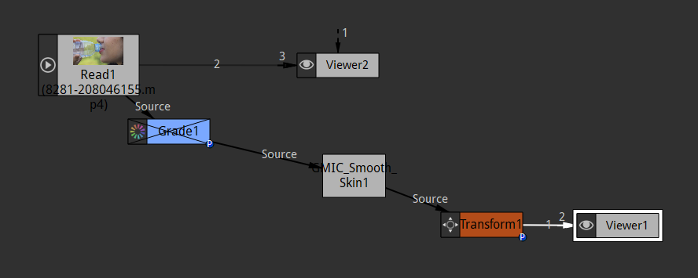

What we do is we will kind of zoom in do we will start back at frame 1 and then we slowly zoom in the shot a little bit so we will just do like we will scale and make the image larger which kind of creates the zoom in effect so by default so at frame 1 we go to Transform property in properties panel and then right click on the scale and then click on Set Key ( all dimensions )

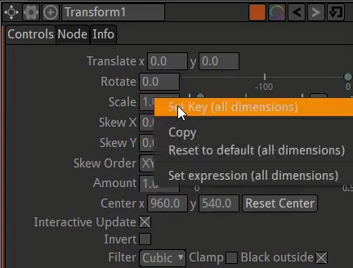

And now its field is in blue color as shown below so keyframe is added in frame 1

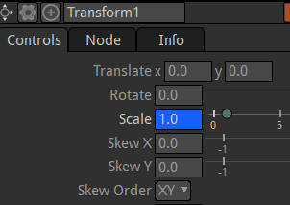

And then we go to frame 20 Now scale field is light blue in color (as shown below)as no keyframe is added since no value of scale is changed

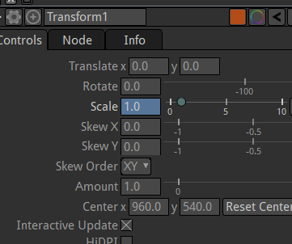

We make the scale 1.25 now scale field will be in blue color as shown below

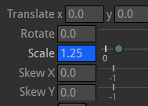

Now we play again now it will take a time to render it but we will see it just zooming in and see how that works We write it so we can see the output without it being buffer

And now we add out write node to the transform node ( as it is the last node connected to viewer node ) as shown below

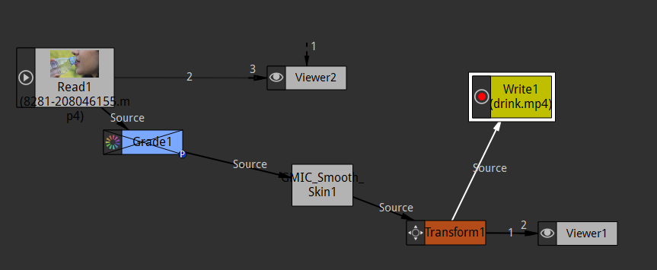

We will name our video as drink.mp4

Remember that when we press ctrl and hold it then there is a point between line connecting between two nodes as marked below

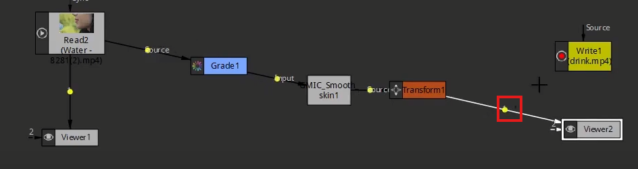

If we hover over it by pointer(ctrl is still in hold ) then the mouse pointer will be converted into hand and then you drag there will be joint between the line as shown below

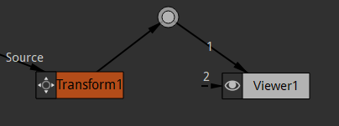

Now we can connect any other node to the joint ( it is the same as multiple nodes are connecting to the one node (according to my postulates the node that will be connected to joint will get access to the same data as the viewer is getting ))

Now we connect out write node to the joint as shown below

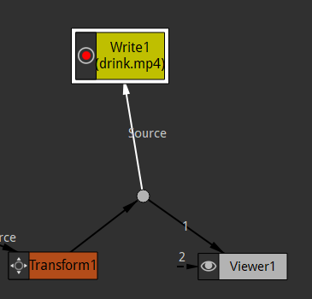

Now our node graph will look like below

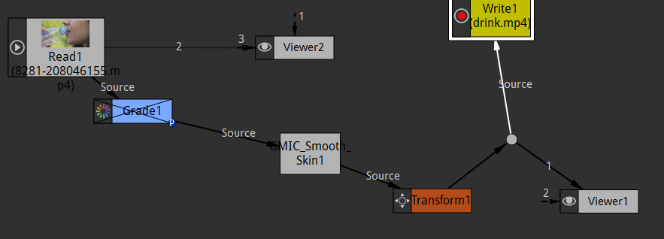

So all the thing going out to viewer is also going out to the write node.

Now we check writer properties to make sure everything is fine

So we can see out fps in writer node as marked below

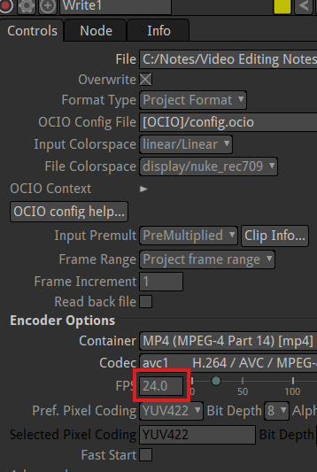

The above is the codec or container we are using (who knows) So now we click on render button and it will take a while to render probably but it get failed as shown in progress tab

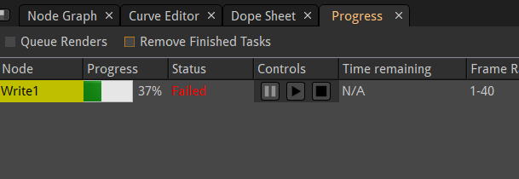

Why is it so lets see out writer node and make sure the destination is probably is OK t write to

Project format is probably good but it might not be good (who knows)as marked below in writer properties

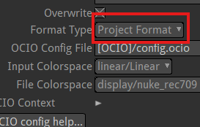

So may be we are forcing so we go to read node and then uncheck the custom fps as marked below

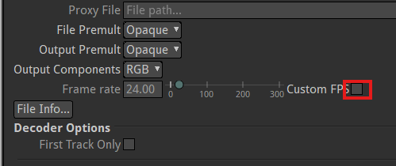

I think it is because the read node has a default fps and we were just forcing it to match with project fps (which maybe not good) so when we uncheck ut thewn it come back to its original value (research it later) so it is recommended to make a read node fps and project fps match while building the project and make the read node back to its original fps while writing (Research later)

So we rerender it now it will be successfully out putted as shoen below in progress tab

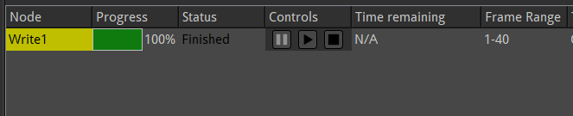

Okay Now our video will look like below



It is god we don’t have that artifacting (distortion of video) new got the smooth skin applied with smooth skin filter The reason that we failed the first time because we had in our read node which teacher told us to change the fps of read node to match viewer node but Teacher was wrong we checked the custom fps in read node properties and forced it to be 24 fps well that was messing things up a bit and caused a problem so we will just keep this read node fps as it is. If you have to match then change the project fps to match read node(case in which there is only one read node)

We did not change it but we could change the project frame rate to match the read node

16:54

(Teacher pagal ho gaya keep retrying it will output the video)

Its gonna be really good to do especially if we have like 24 frames per second in our project and 30 fps for our video

So this video that we edited and exported hopefully is kind of showing some different option for cleaning up video and kind of some of the nuances of importing and exporting video and that’ really you just have to learn and get experience with you will export it and have black boxes or artifacting something crazy(maybe happens in exported videos who knows ) and you have to change maybe the container that you are using as marked below

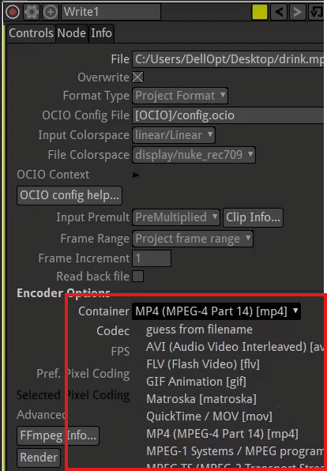’

You can choose mov instead of mp4 or avi. You can change your codec play with your frame per second like those are the most common things that give you some errors or trouble while exporting the video See you in the next lesson.